TASK 8 – Polymorphism and Method Overloading

Aim
To understand compile-time polymorphism through method overloading and runtime polymorphism through method overriding in the Campus Smart-Parking System.

1. Method Overloading
Method overloading means defining multiple methods with the same name but different parameter lists.
Example:
double calculateFee(int hours) {
return hours * 50;
}
double calculateFee(int hours, double rate) {
return hours * rate;
}

2. Complete Java Program – FeeDemo.java
class Vehicle {
double calculateFee(int hours) {
return hours * 50;
}
double calculateFee(int hours, double rate) {
return hours * rate;
}
}
class Car extends Vehicle {
@Override
double calculateFee(int hours) {
return hours * 60;
}
}
public class FeeDemo {
public static void main(String[] args) {
Vehicle v = new Vehicle();
System.out.println("Fee: " + v.calculateFee(2));
System.out.println("Fee: " + v.calculateFee(3, 40));
Vehicle c = new Car();
System.out.println("Car Fee: " + c.calculateFee(2));
}
}
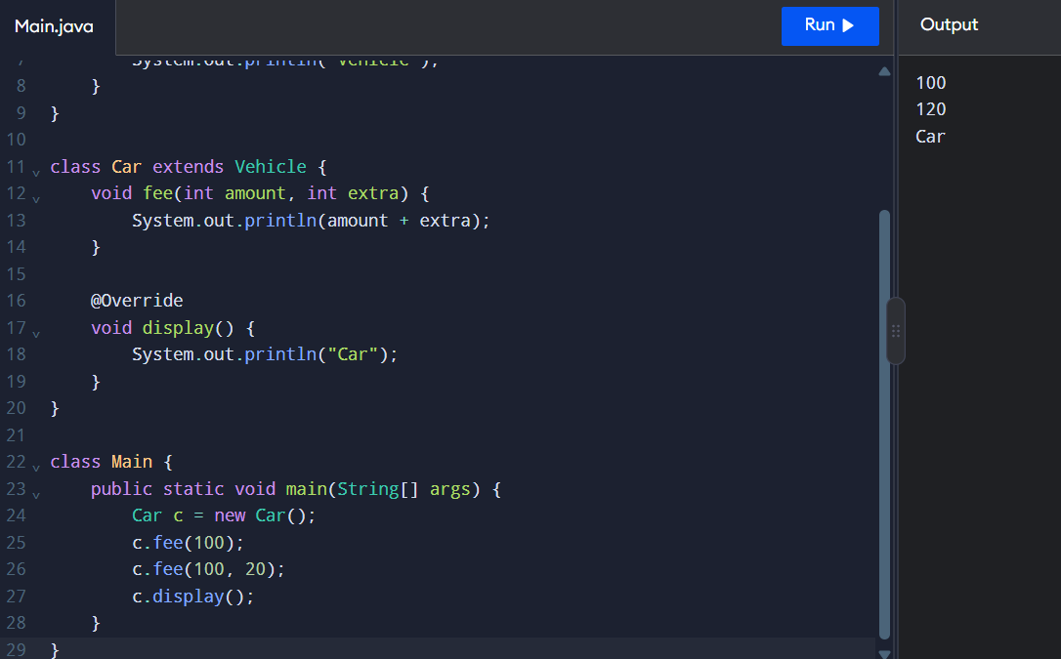

3. Expected Output
Fee: 100.0
Fee: 120.0
Car Fee: 120.0

4. Explanation
- Method overloading: Methods have the same name but different parameters.
- Compile-time polymorphism: The compiler selects the overloaded method based on the arguments.
- Method overriding: A child class provides its own implementation of a parent-class method.
- Runtime polymorphism: The overridden method is selected according to the actual object type.
- Dynamic method dispatch: Vehicle c = new Car(); calls the Car implementation of calculateFee(2).

5. Overloading vs Overriding

Method Overloading | Method Overriding
Same method name with different parameters. | Same method signature in parent and child classes.
Usually occurs within the same class. | Requires inheritance.
Compile-time polymorphism. | Runtime polymorphism.
Return type alone cannot distinguish overloaded methods. | Return type must be compatible with the parent method.
Example: calculateFee(2, 40). | Example: Car overrides calculateFee(2).

Result
Method overloading and method overriding were implemented successfully. The program demonstrates compile-time polymorphism, runtime polymorphism, and dynamic method dispatch in Java.

